**Logic App Secure File Transfer Demo**

Trigger

When blob is added or modified

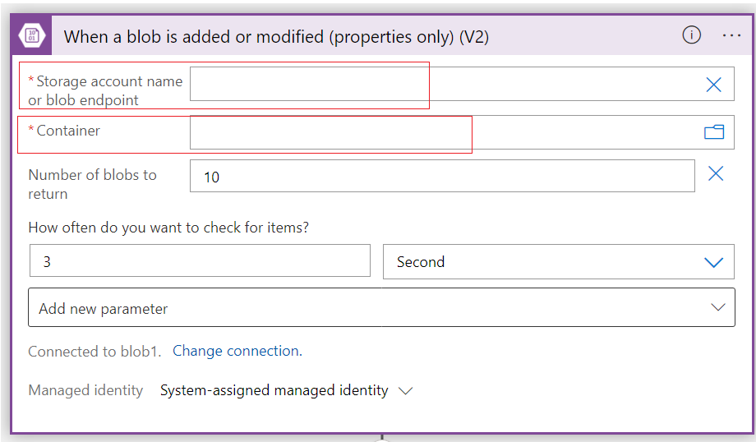

|  |  |
| --- | --- |
| Storage Account Name or Blob Endpoint | <your storage account name> |
| Container | <container name> |

Get blob content

* Add dynamic content to select ‘List of Files Display Name’. Example provided in screenshot below.

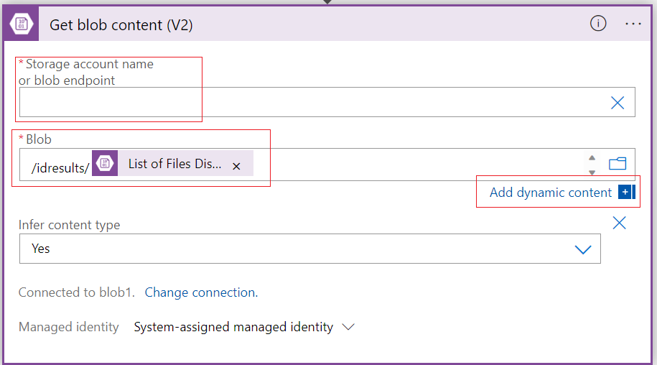

|  |  |
| --- | --- |
| Storage Account Name or Blob Endpoint | <your storage account name> |
| Blob | <container path>/List of Files Display Name |

ParseJSON

* On add dunamic content, select expression and search for json(), then add ‘Get blob content’ from dynamic content as a parameter.
* Select ‘Use sample payload to generate schema’, enter or paste a sample JSON payload, and click Done.

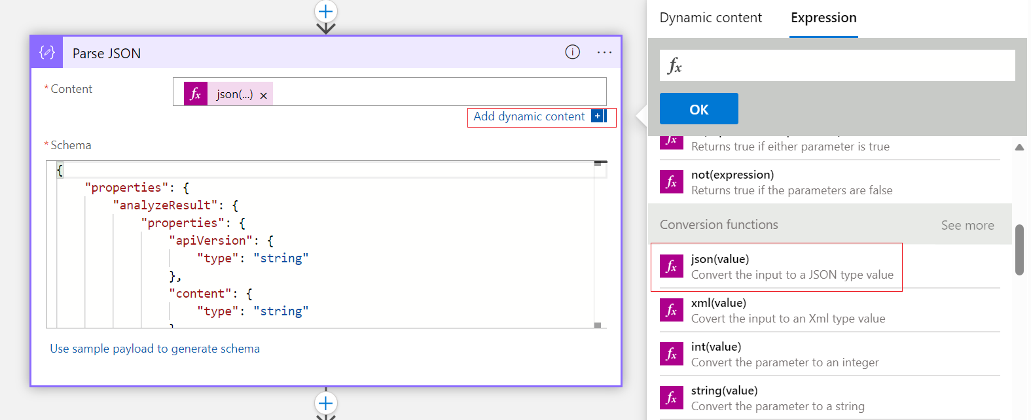

|  |  |
| --- | --- |
| Content | Json(body(‘Get_blob_content_(V2)’)) |
| Schema | <Copy and Paste your JSON Schema> |

For each

* On add dynamic content, select the target JSON object under Parse JSON for selected output.

|  |  |
| --- | --- |
| Select Output from previous step | <target JSON array/object> |

Action within For each

SharePoint - Create item

* On add dynamic content, select the target JSON object under Parse JSON for each parameter value. Example provided below.

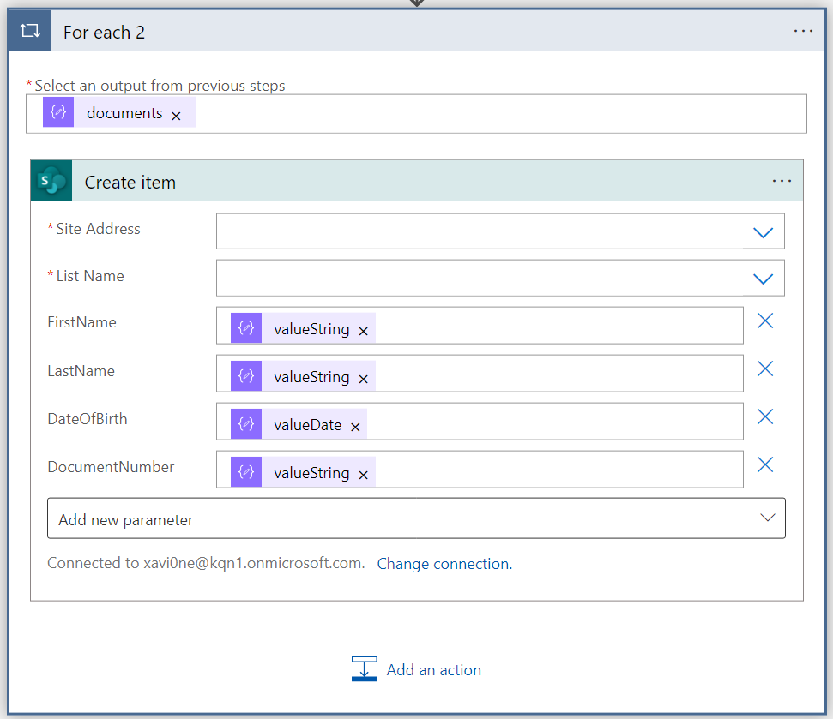

|  |  |
| --- | --- |
| Site Address | <SharePoint URL> |
| List Name | <your list name> |
| Parameters | <target parameter to map with JSON object> |

* Ensure to click save at the top.